Sprinklr is the unified platform for all customer-facing functions. We call it unified customer experience management (Unified-CXM). We help companies deliver human experiences to every customer, every time, across any modern channel, at a once impossible scale. Sprinklr is headquartered in New York City with over 3,000 employees globally. Sprinklr has 25 offices in 16 countries with R&D primarily based out of India, Singapore and Dubai. Sprinklr works with more than 1,000 of the world’s most valuable enterprises — global brands like Microsoft, P&G, Samsung and more than 50% of the Fortune 100. Learn more about our culture and how we make our employees happier through The Sprinklr Way
What will you do:
- Create buy-in for the product vision both internally and with key external partners
- Determine customers' needs by specifying the research needed to obtain market information
- Recommend the nature and scope of present and future product lines by reviewing product specifications and requirements, appraising new product ideas and/or product or packaging changes
- Assesses market competition by comparing the company's product to competitors' products
- Assesses product market data by calling on customers with field salespeople and evaluating sales call results
- Provides information for management by preparing short-term and long-term product sales forecasts and special reports and analyses, answering questions and requests
- Brings new products to market by analyzing proposed product requirements and product development programs; preparing return-on-investment analyses; establishing time schedules with engineering and manufacturing
- Introduce, market maintain new and old products by developing time-integrated plans with sales, marketing, and field teams.

What Makes you qualified:
- Ability to work both independently and in cooperation with others
- A sense of urgency and ownership over the product
- Comfortable with full-stack projects and able to build a minimum working product quickly
- Fluency with back-end technologies/front-end technologies
- Thrives in open or ambiguous environment
- Great attitude towards work and people
- Intellectually curious and inventive

Why you'll love Sprinklr: We’re committed to creating the kind of culture where you feel like you belong, are happier today than yesterday, and your contributions matter. At Sprinklr, our goal is to treat everyone like family and passionately, genuinely care. For full-time employees, we offer flexible paid time off and paid parental leave, medical plans, dental and vision plans, life insurance, 401(k) savings plans, employee stock options, gym and wellness discounts, Plum benefits, Lifemart discounts, and paid time off to invest in learning and career development.
We focus on our mission: We founded Sprinklr with one mission: to enable every organization on the planet to make their customers happier. Our vision is to be the world’s most loved enterprise software company, ever.
We believe in our product: Sprinklr was built from the ground up to enable a brand’s digital transformation. Its platform provides every customer-facing team with the ability to reach, engage and listen to customers around the world. At Sprinklr, we have many of the world's largest brands as our clients, and our employees have the opportunity to work closely alongside them.
We invest in our people: At Sprinklr, we believe every human has the potential to be amazing. We empower each Sprinklrite in the journey toward achieving their personal and professional best. For wellbeing, this includes daily meditation breaks, virtual fitness, and access to Headspace. We have continuous learning opportunities available with Audible for Business, LinkedIn Learning, and more.
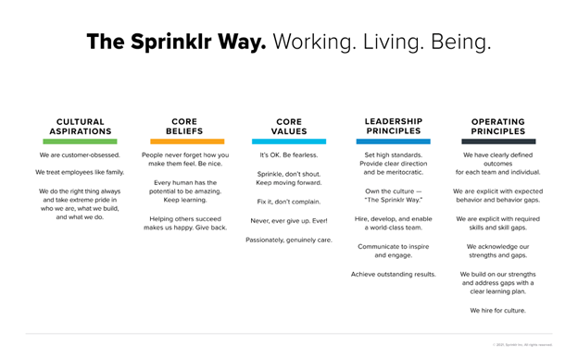
EEO - Our philosophy: Our goal is to ensure every employee feels like they belong and are operating in a judgement-free zone regardless of gender, race, ethnicity, age, and lifestyle preference, among others. We value and celebrate diversity and fervently believe every employee matters and should be respected and heard. We believe we are stronger when we belong because collectively, we’re more innovative, creative, and successful.
Sprinklr is proud to be an equal opportunity workplace and is an affirmative action employer. We are committed to equal employment opportunity regardless of race, color, ancestry, religion, sex, national origin, sexual orientation, age, citizenship, marital status, disability, gender identity or Veteran status. See also Sprinklr’s EEO Policy and EEO is the Law. If you have a disability or special need that require accommodation, please let us know.

Note: There will be 3 PERSONAL INTERVIEWS.
BGC - Degree, experience letters, etc required
CTC of 30 LPA is entirely a fixed component with no variable component

